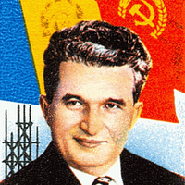

<https://www.google.com/url?sa=i&url=https%3A%2F%2Fpicryl.com%2Fmedia%2Fnicolae-ceausescu-7b8ab5&psig=AOvVaw2x4PYYdQTVajJdudjDB0fI&ust=1740853374437000&source=images&cd=vfe&opi=89978449&ved=0CBkQjhxqFwoTCNiXq6r-5osDFQAAAAAdAAAAABAE>

<https://www.google.com/url?sa=i&url=https%3A%2F%2Fcommons.wikimedia.org%2Fwiki%2FFile%3AArdeal_1945_Buc.jpg&psig=AOvVaw0PC52uR7lKqx4TCjnlXrZo&ust=1740853983998000&source=images&cd=vfe&opi=89978449&ved=0CBkQjhxqFwoTCJCWzdOA54sDFQAAAAAdAAAAABBQ>